Homework 3
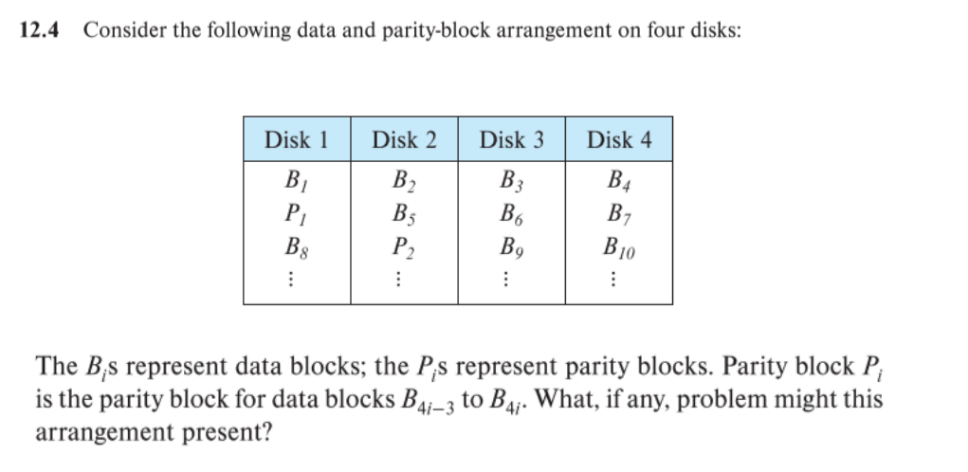since the parity block and $B_{4i-3}$ are on the same disk, if the disk fails, rebuilding $B_{4i-3}$ is impossible since the data and parity block are both lost
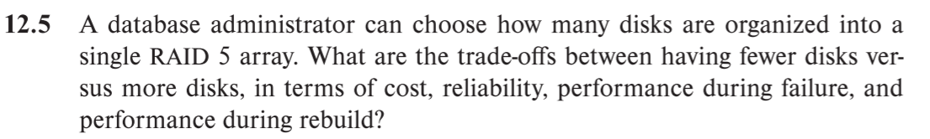
In a RAID 5 configuration, the trade-offs between having fewer disks versus more disks can include:
Cost: Having fewer disks generally means a lower upfront cost for purchasing the disks and installing the RAID configuration. However, having fewer disks also means less capacity for storing data, which may require more frequent upgrades or additional storage solutions in the future.
Reliability: Having more disks in a RAID 5 configuration can improve reliability by providing more redundancy in case of disk failure. However, having more disks also means that there is a higher likelihood of experiencing a disk failure due to the increased number of disks, which could potentially impact the reliability of the system.
Performance during failure: In the event of a disk failure, a RAID 5 configuration with fewer disks may experience a greater performance impact compared to a configuration with more disks due to the reduced capacity for storing data.
Performance during rebuild: After a disk failure, the RAID 5 configuration will need to rebuild the data on a replacement disk. This process can impact performance, and a RAID 5 configuration with more disks may experience a greater performance impact during the rebuild process due to the increased overhead for calculating and storing the parity information
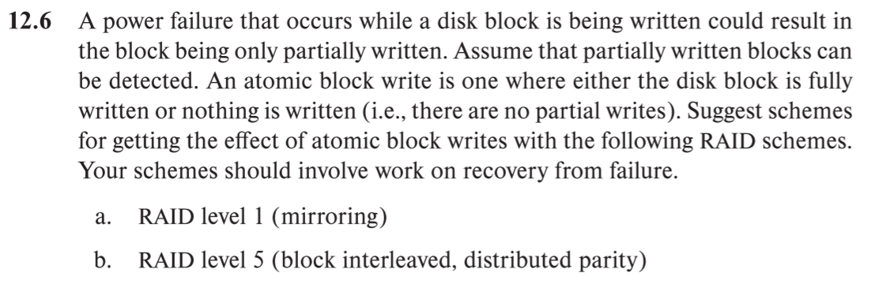a. RAID level 1 (mirroring)
One way to achieve the effect of atomic block writes in a RAID 1 configuration is to write the data to one of the mirrors, and then simultaneously write the data to the other mirror. If a power failure occurs while the data is being written, the partially written data will be detected and the write operation can be rolled back, ensuring that the data is either fully written or not written at all.
b. RAID level 5 (block interleaved, distributed parity)
One way to achieve the effect of atomic block writes in a RAID 5 configuration is to write the data to one of the disks in the RAID group, and then simultaneously write the data to the remaining disks in the group along with the parity information. If a power failure occurs while the data is being written, the partially written data will be detected and the write operation can be rolled back, ensuring that the data is either fully written or not written at all. Alternatively, the data can be written to a cache or buffer and then committed to the disks in the RAID group in an atomic operation, to achieve the same effect.

